1, Open the inversion software ZondRes2D (version 6.1, build Zondres2d20200415-64bit-stable) and perform inversion processing on the raw data contained in the Excel table.
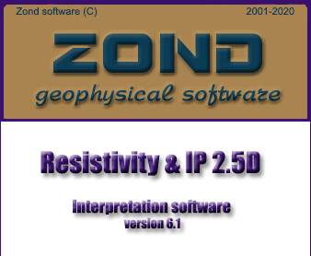
2, In the menu, go to File → Import data from text/excel and select the Excel file to import the data.
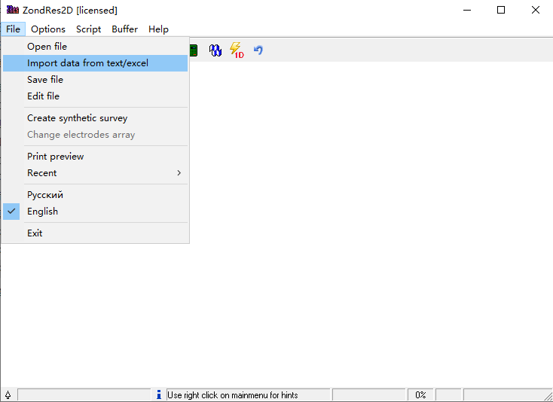
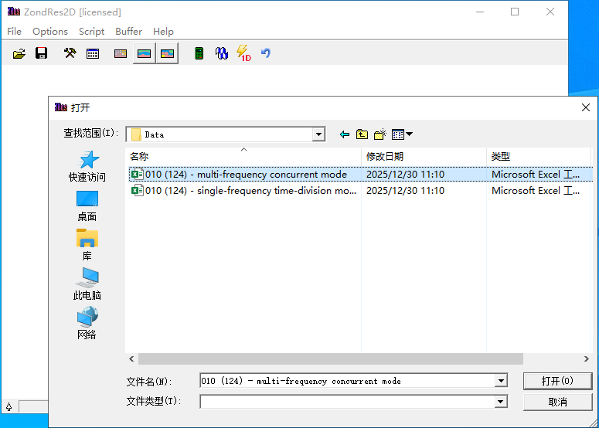
3, Assign the correct meaning to each column in the imported table. Select the IP mV/V method for processing. Map the valid data columns in the following order:
- C1x: x-coordinate of current electrode A
- C2x: x-coordinate of current electrode B
- P1x: x-coordinate of potential electrode M
- P2x: x-coordinate of potential electrode N
- ro_a: calculated apparent resistivity (ρ_a) After assigning the columns, click OK to apply the settings.
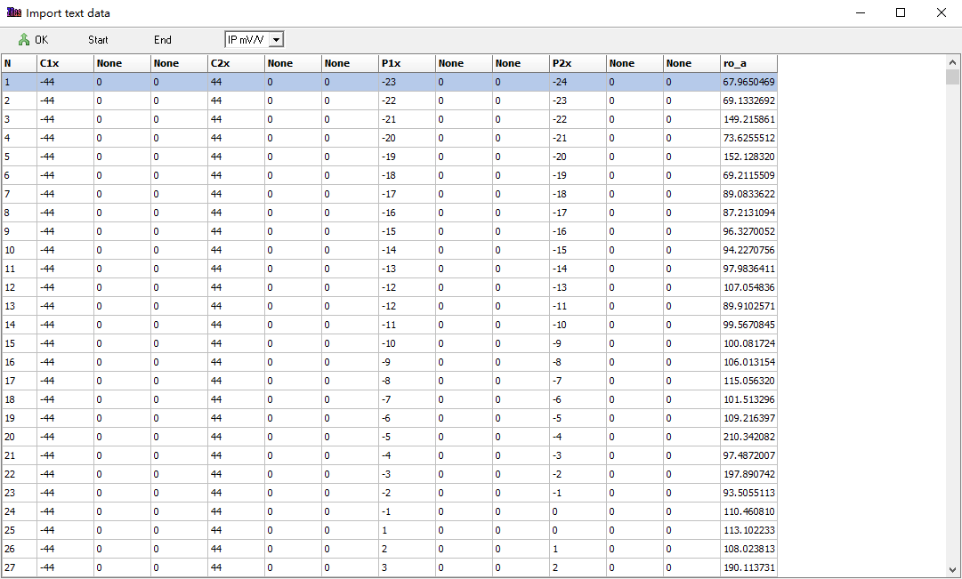
4, Set the Start height (initial depth of the model). Adjust the Layers number to control the Maximal depth. The value of Maximal depth should be estimated based on the four-electrode sounding rule of thumb, typically taken as 1/2 × AB, where AB is the maximum distance between the current electrodes and potential electrodes (i.e., the largest electrode separation used in the survey). After setting these parameters, click Apply.
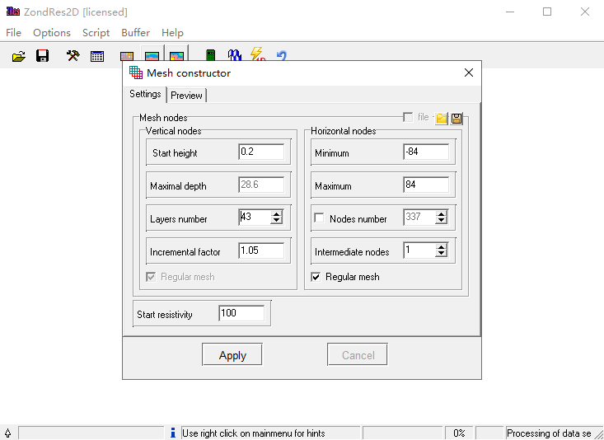
5, Go to Options → Inversion and select the 64-bit version
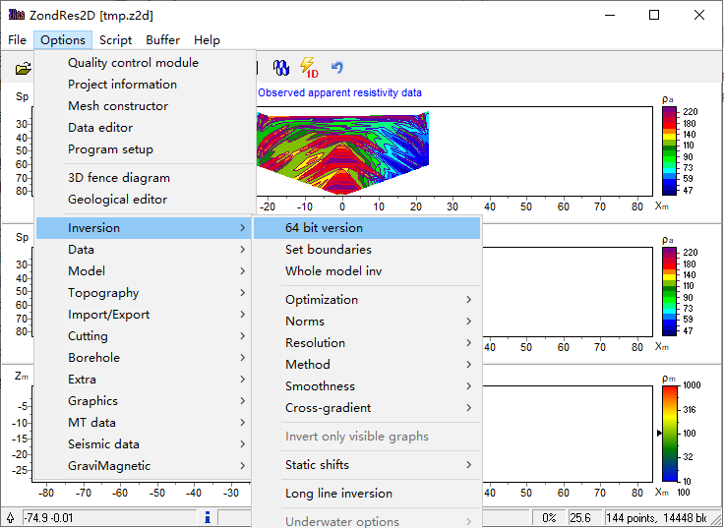
6, Set the Model type to Smooth-section.
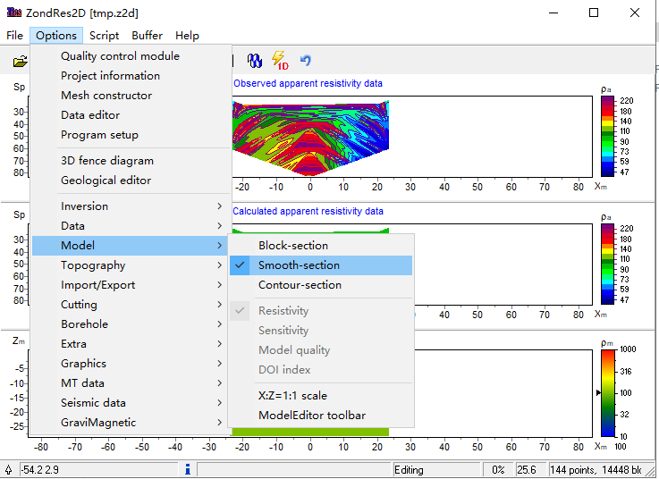
7, Go to Program setup and configure the following inversion parameters:
- Set the number of Iterations (recommended value depends on convergence, commonly 10–30).
- Set the Inversion algorithm to Occam.
- In Model common limits, define the Min resistivity and Max resistivity bounds (e.g., 1–10,000 Ω·m or appropriate values based on the expected geological range)
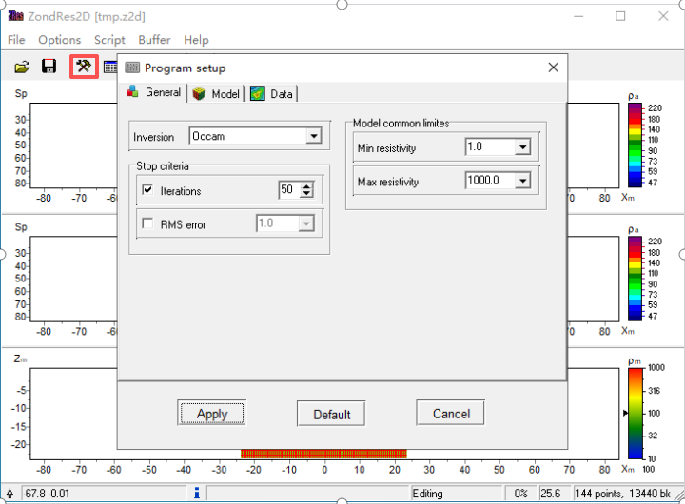
8, Click Start inversion to begin the inversion process
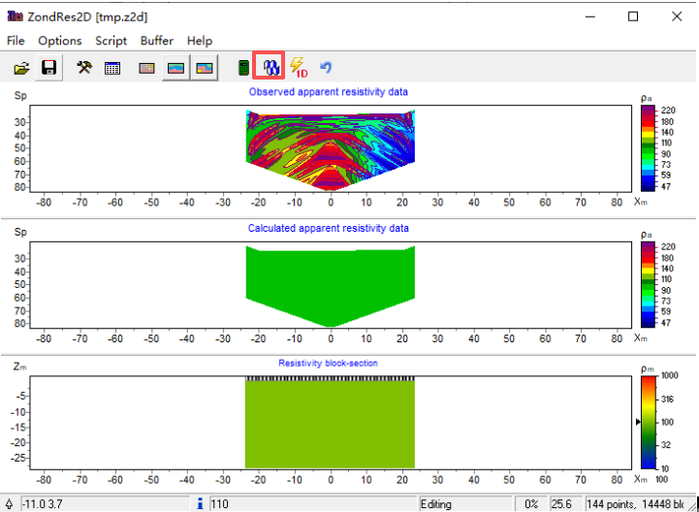
Wait for the inversion to complete. The RMS error value will be displayed at the bottom of the window (in this case, approximately 1.4%).
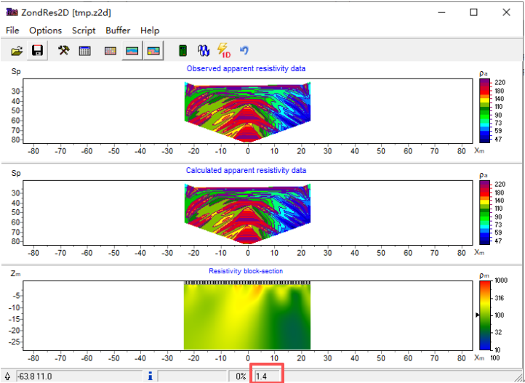
Once satisfied with the result, click the Save (or Save As) button and export the result as a Grid file (*.dat) format. This file will be used later for plotting in Surfer software.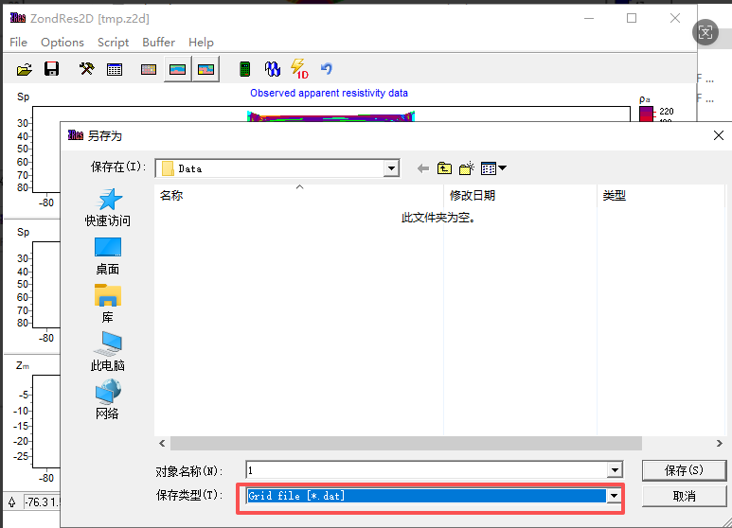
9, Open Surfer software (version information shown in the figure below).
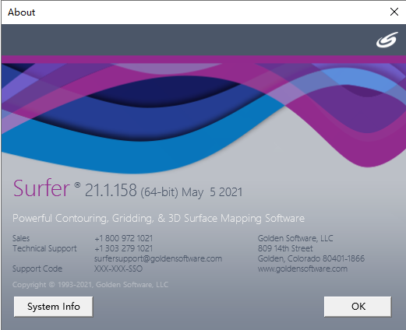
10, In Surfer, go to Grid → Grid Data (or use the corresponding menu depending on the version). Select the previously saved Grid file (*.dat). Assign the correct columns:
- X: horizontal distance (m)
- Y: depth (m, usually negative)
- Z: resistivity value (Ω·m) Click Skip to end (or Next/Finish) to load the grid.
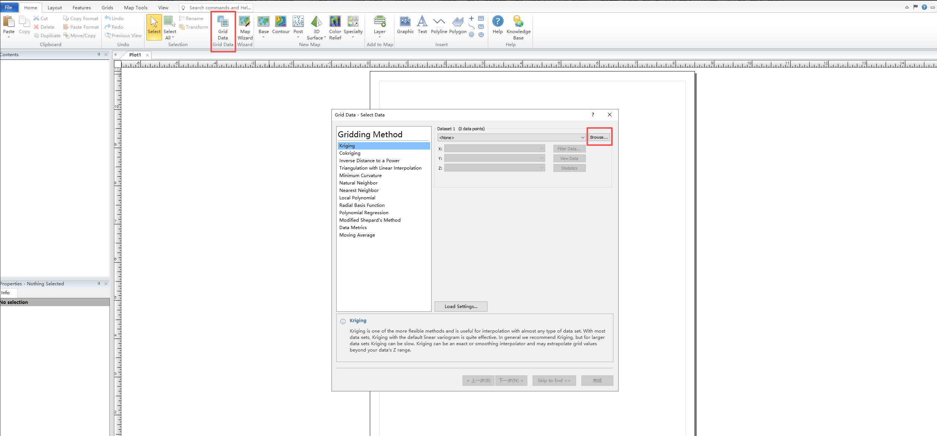
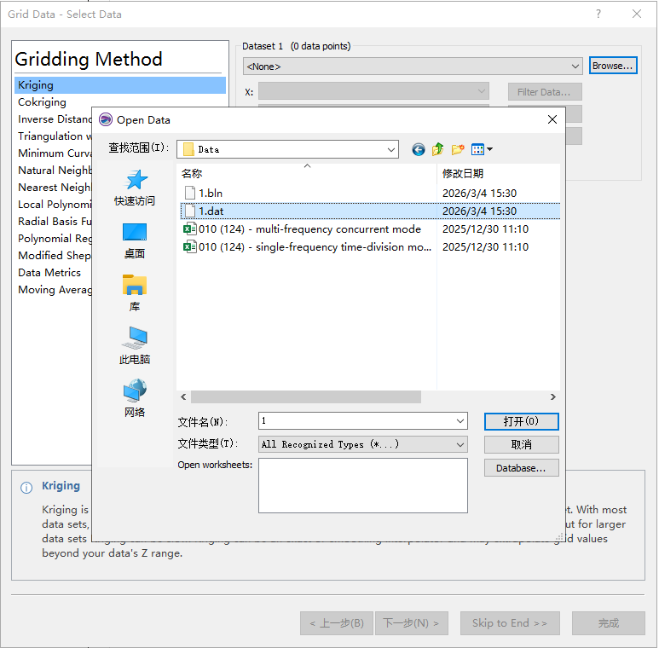
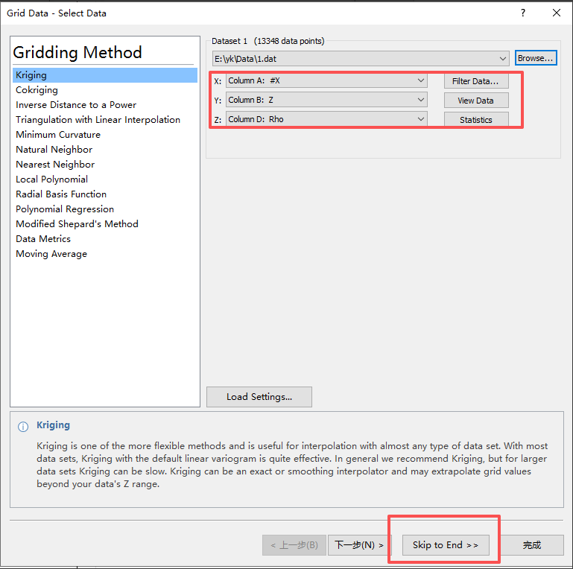
Adjust the display coordinate range as needed (set appropriate limits for X and Y axes to focus on the region of interest).
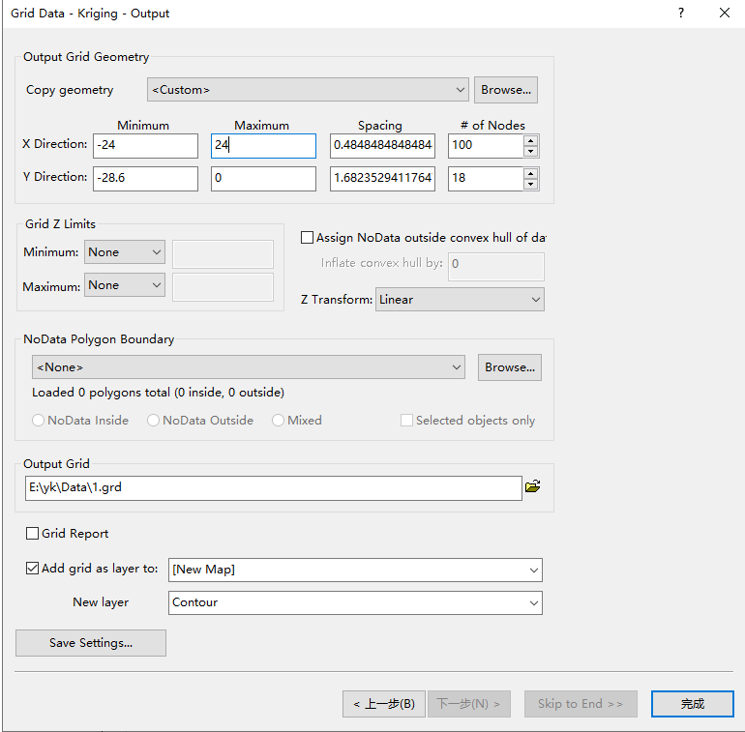
Finally, beautify the image according to the requirements for geological interpretation and publication:
- Add title
- Insert scale bar / color bar
- Apply color filling and contour settings
- Adjust labels, fonts, axis ticks, etc.
After final adjustments, export the figure (e.g., as high-resolution PNG, TIFF, or EPS) to obtain Figure 13 for the paper.
